#GUIDE TO ACCESS THE SCRIPT
#After downloading the documents from the Githut,
#Copy paste the credentials proved in the credential document paste it in the Env .env file.
Step 1:
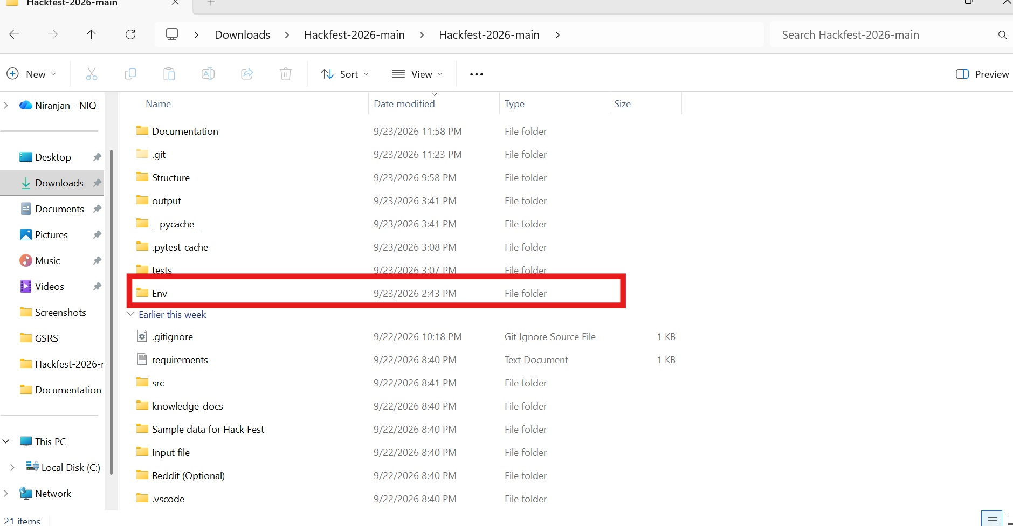

#after that Open the folder containing the documents provided in the Github.
#In the folder path open CMD Type: python -m streamlit run app.py 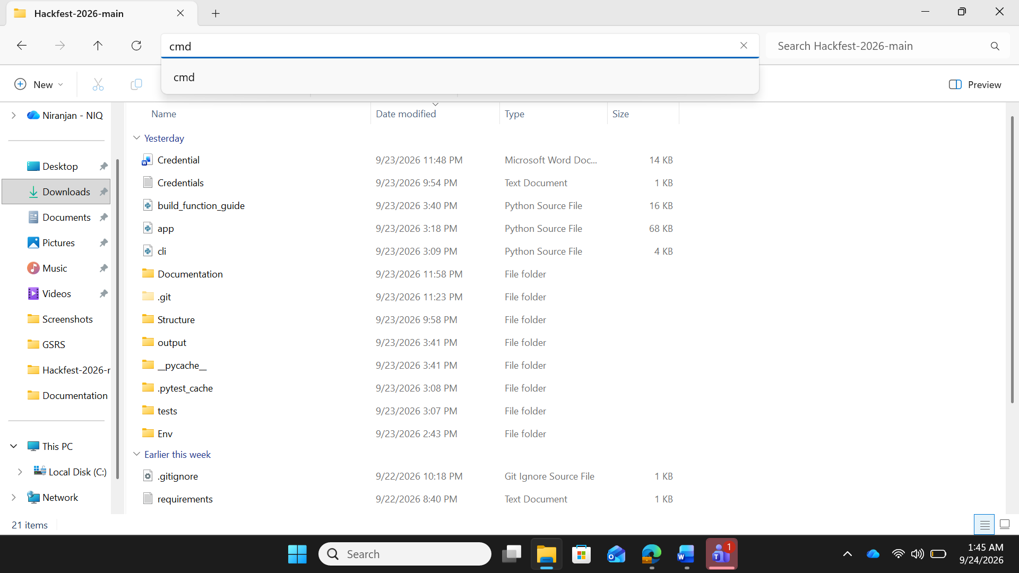
#Step 2:
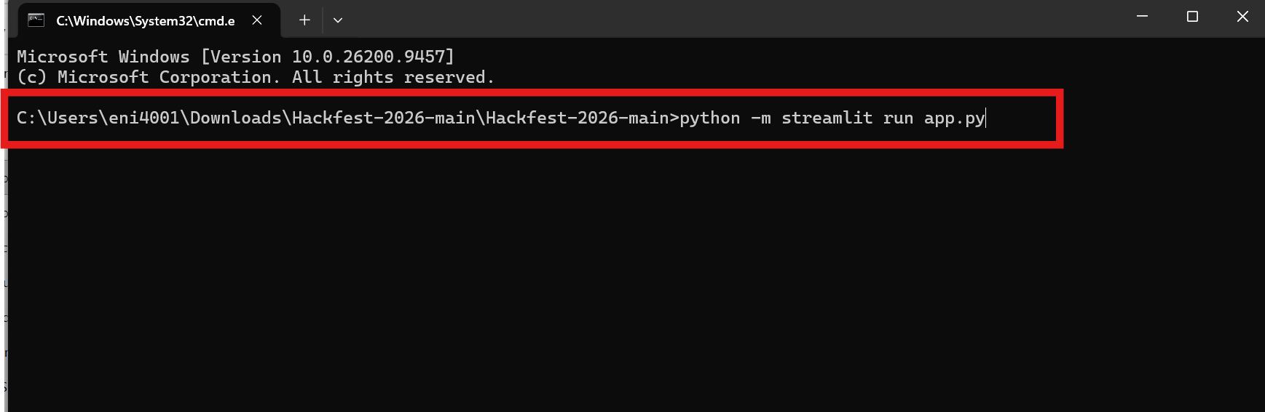
Step 3:
